Name ____________________________________________________________________ Hour____________

**12.5 & 12.6 Word Problems**

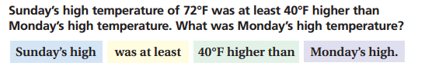**12.5**

variable _________________________________  
   
Inequality_________________________________ Solution set________________________________

Answer phrase______________________________

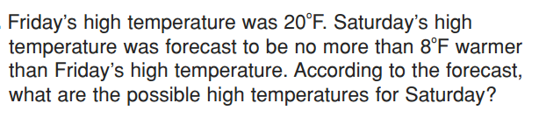

variable _________________________________  
   
Inequality_________________________________ Solution set________________________________

Answer phrase______________________________

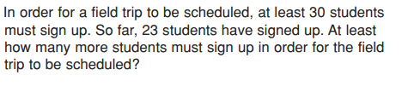

variable _________________________________  
   
Inequality_________________________________ Solution set________________________________

Answer phrase______________________________

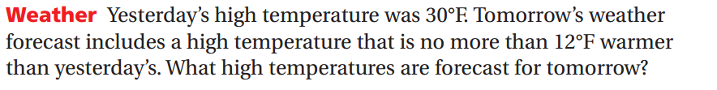

variable _________________________________  
   
Inequality_________________________________ Solution set________________________________

Answer phrase______________________________

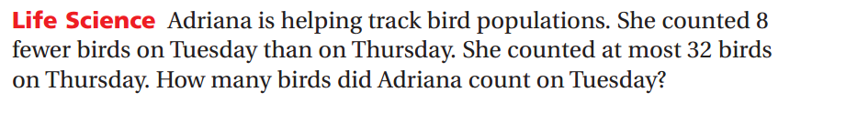

variable _________________________________  
   
Inequality_________________________________ Solution set________________________________

Answer phrase______________________________



variable _________________________________  
   
Inequality_________________________________ Solution set________________________________

Answer phrase______________________________

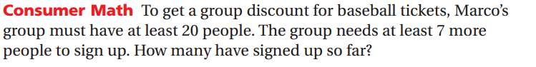

variable _________________________________  
   
Inequality_________________________________ Solution set________________________________

Answer phrase______________________________

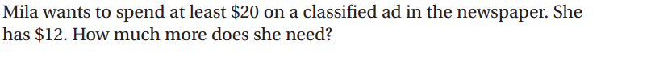variable _________________________________  
   
Inequality_________________________________ Solution set________________________________

Answer phrase______________________________

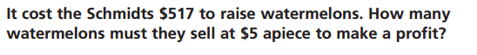**12.6**

variable _________________________________  
   
Inequality_________________________________ Solution set________________________________

Answer phrase______________________________

variable _________________________________  
  
Inequality_________________________________ Solution set________________________________

Answer phrase______________________________

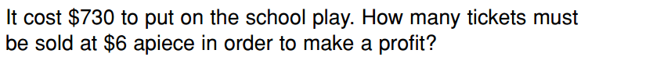

variable _________________________________  
   
Inequality_________________________________ Solution set________________________________

Answer phrase______________________________

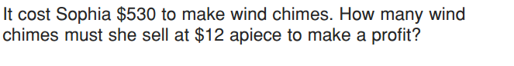

variable _________________________________  
   
Inequality_________________________________ Solution set________________________________

Answer phrase______________________________

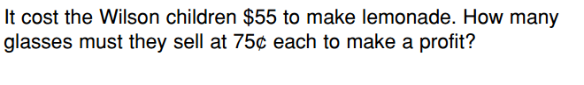

variable _________________________________  
   
Inequality_________________________________ Solution set________________________________

Answer phrase______________________________

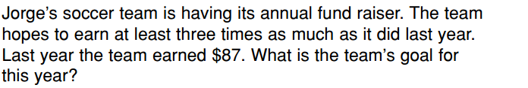

variable _________________________________

Inequality_________________________________ Solution set________________________________

Answer phrase______________________________

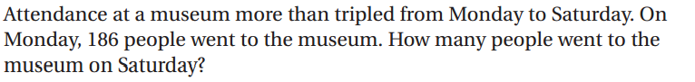

variable _________________________________  
   
Inequality_________________________________ Solution set________________________________

Answer phrase______________________________

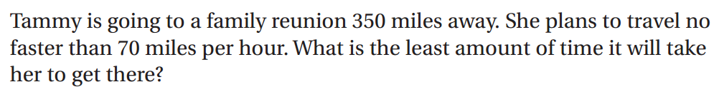

variable _________________________________  
   
Inequality_________________________________ Solution set________________________________

Answer phrase______________________________